BIT 4107 – Mobile Application Development
Student Name: Mongare Naom
Admission Number: BIT/2024/59115
School/Faculty: Computing and Informatics
Programme: Bachelor in IT
Academic Year: Third year
Semester: 2
Lecturer: HOD. Mr. Michael Nyoro
Phone Number: 0742455670

Week 6: Networking and APIs and Week 7: Application Architecture
Tools used:
Frontend- Flutter, Dart, VS Code
Backend- Firebase Auth, Firestore, SQLite
Networking- Firebase SDK, Connectivity Plus
Payments - M-Pesa API (simulated), Payment methods
Attendance- QR Flutter, Attendance sessions
Version Control- Git, GitHub
Testing- Android Emulator, Chrome Browser

- Client-Server Login Screen
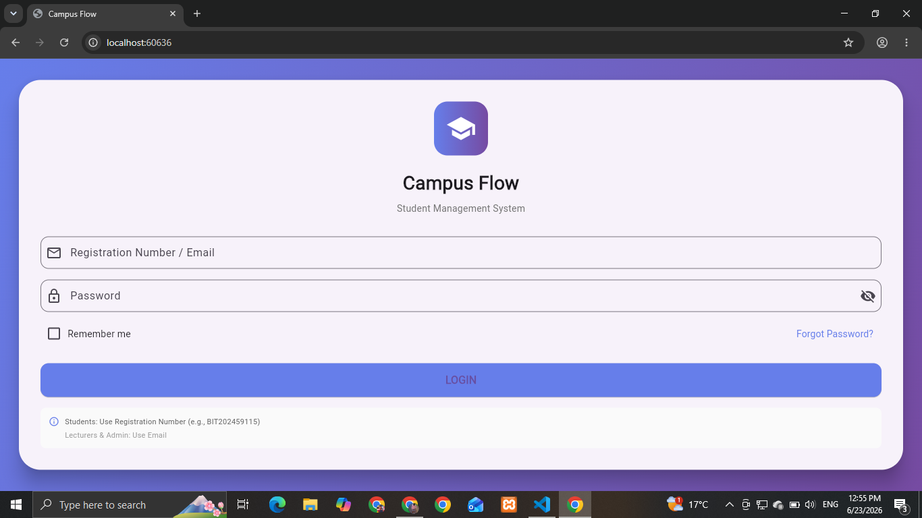

- Student Dashboard (Online Data)
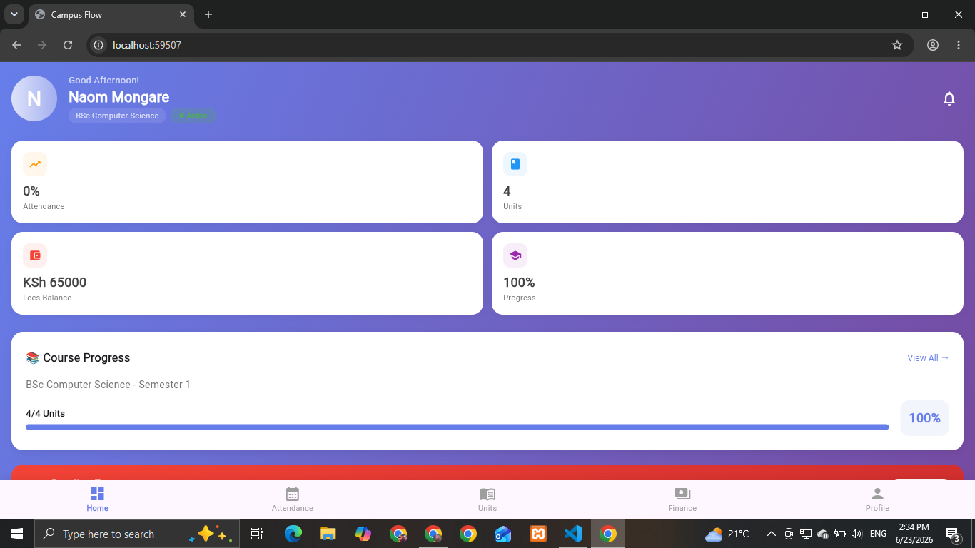
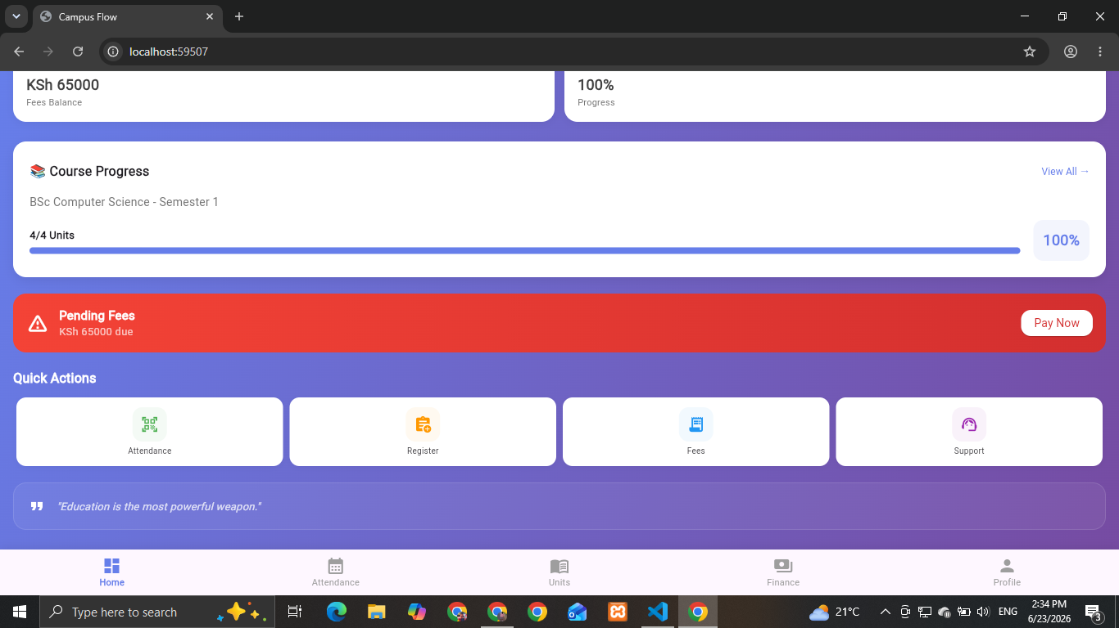
- Lecturer Dashboard
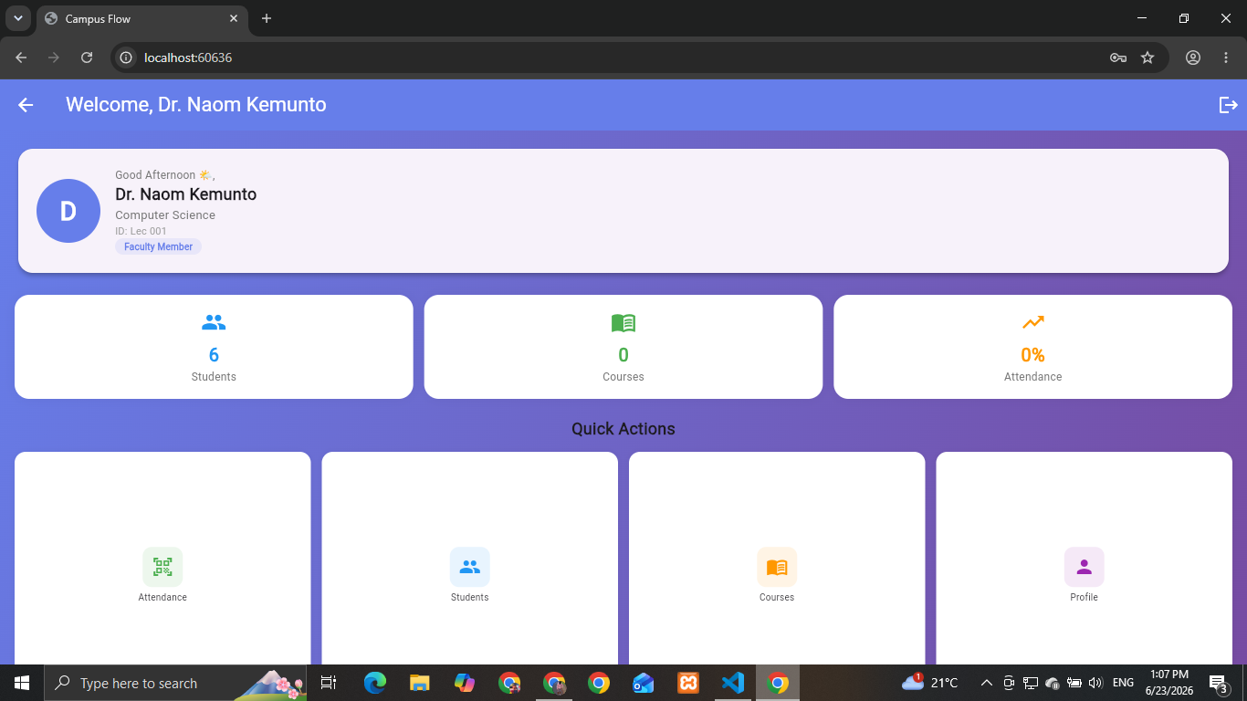
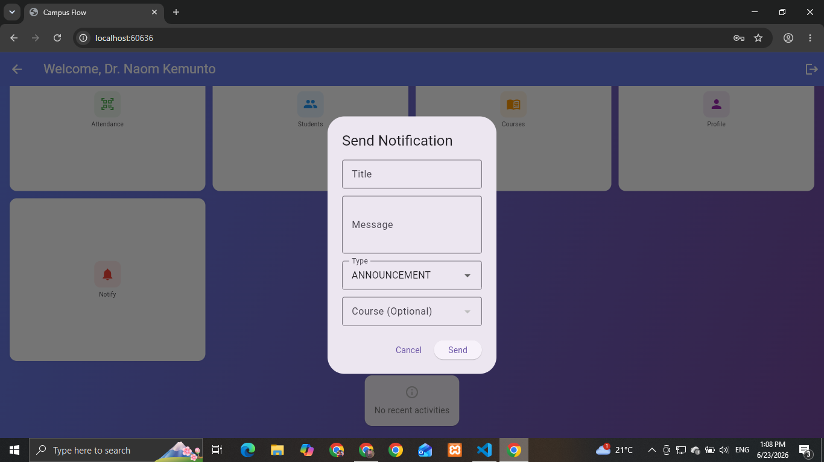
- Admin Dashboard
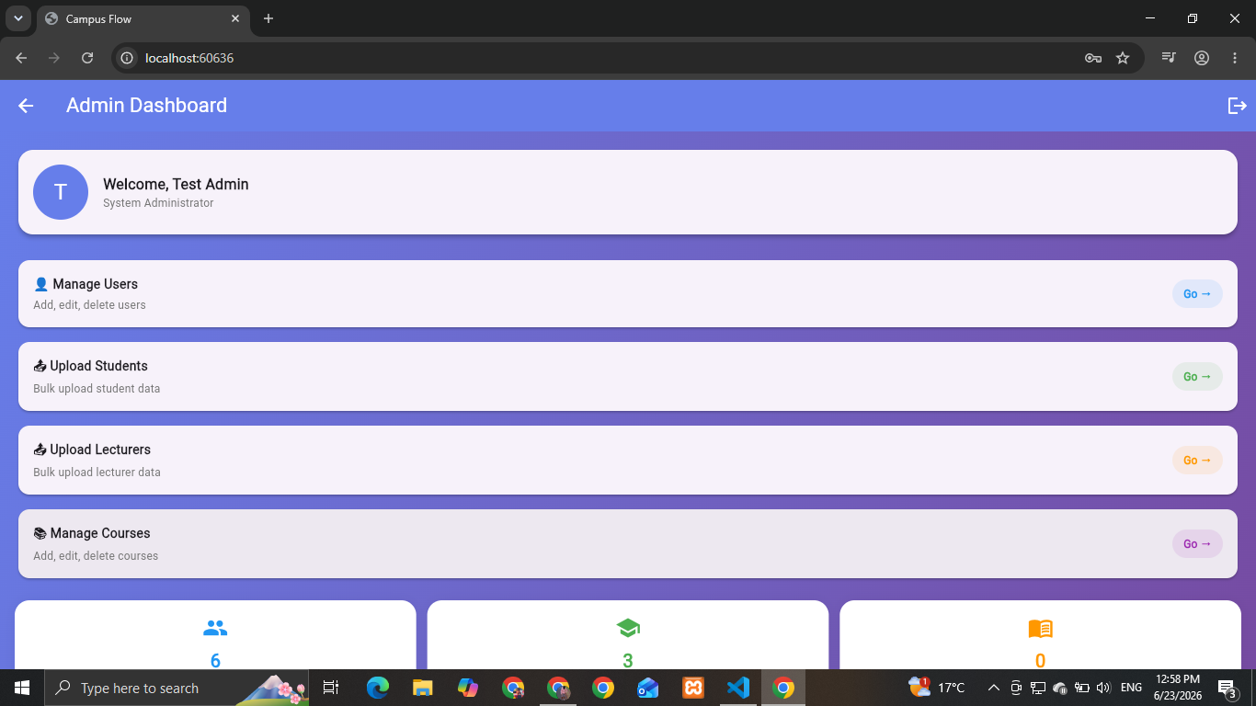
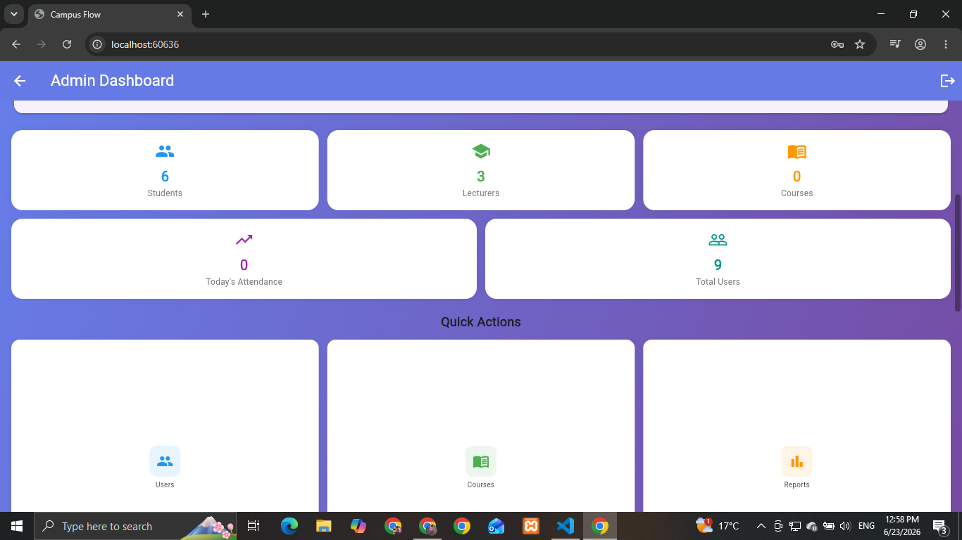
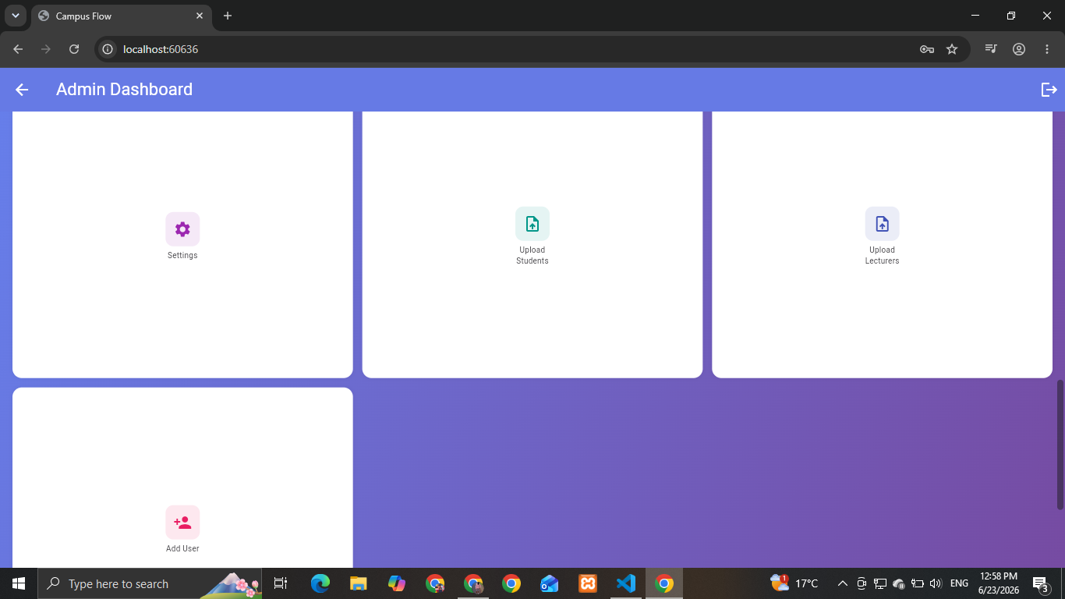
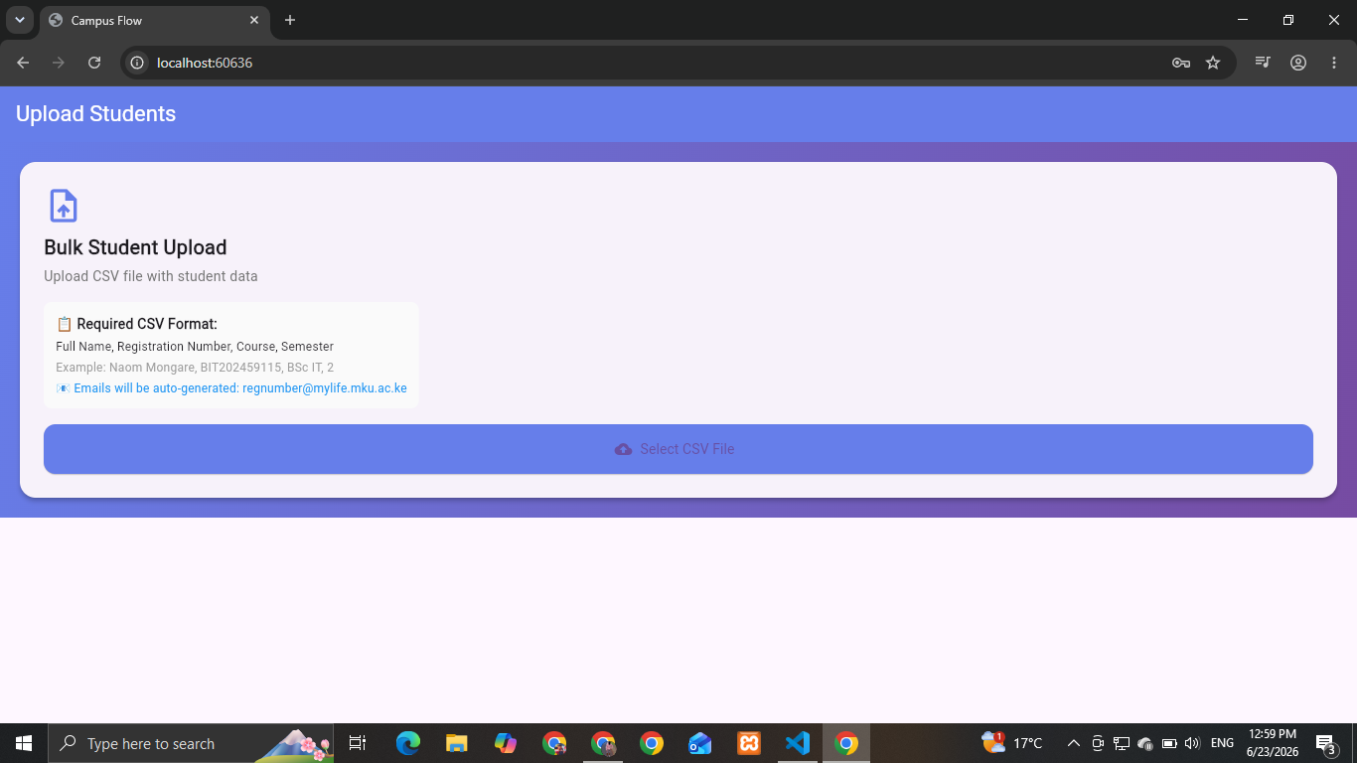
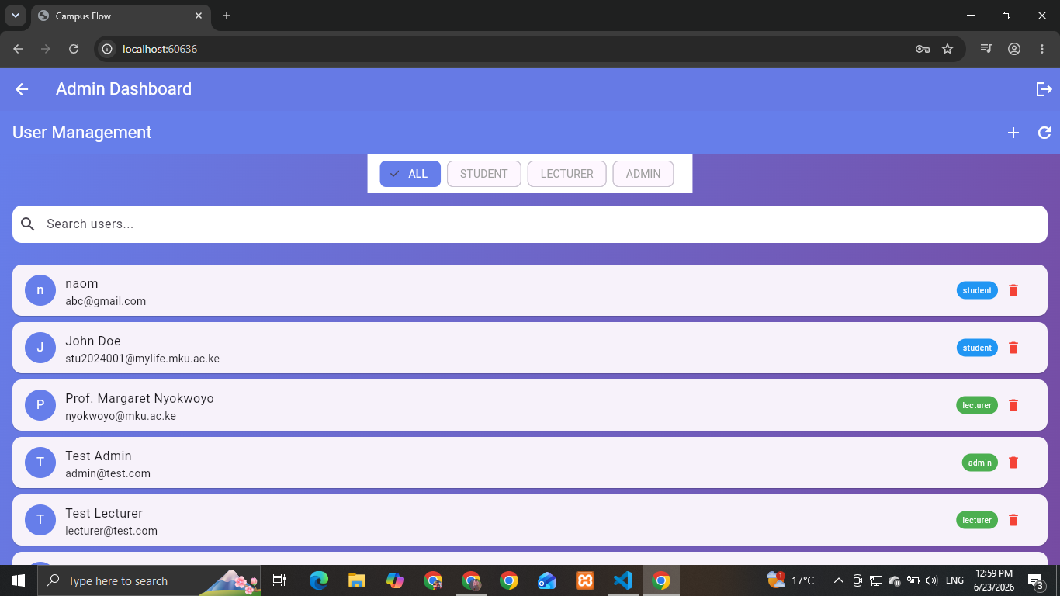
- Student Profile (Database Data)
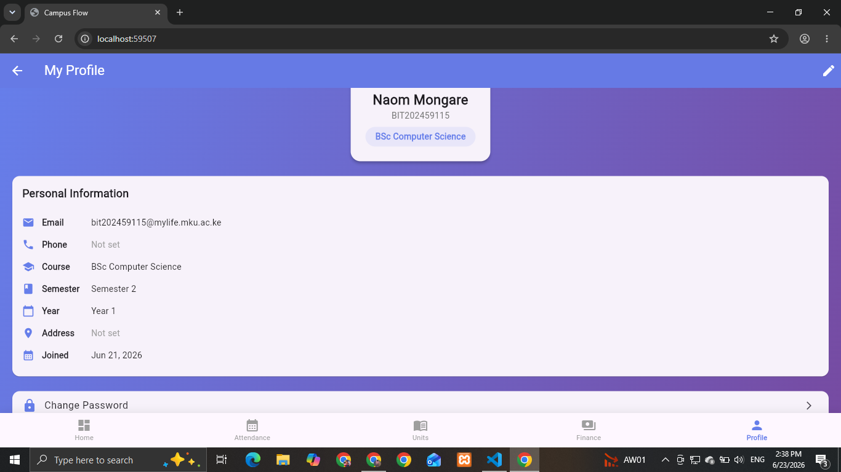
- Unit Registration
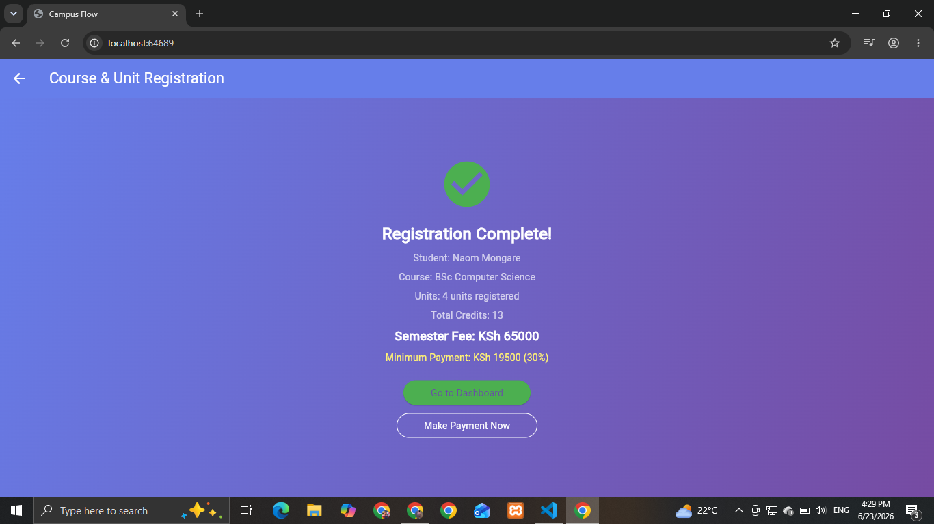
- Fees Screen
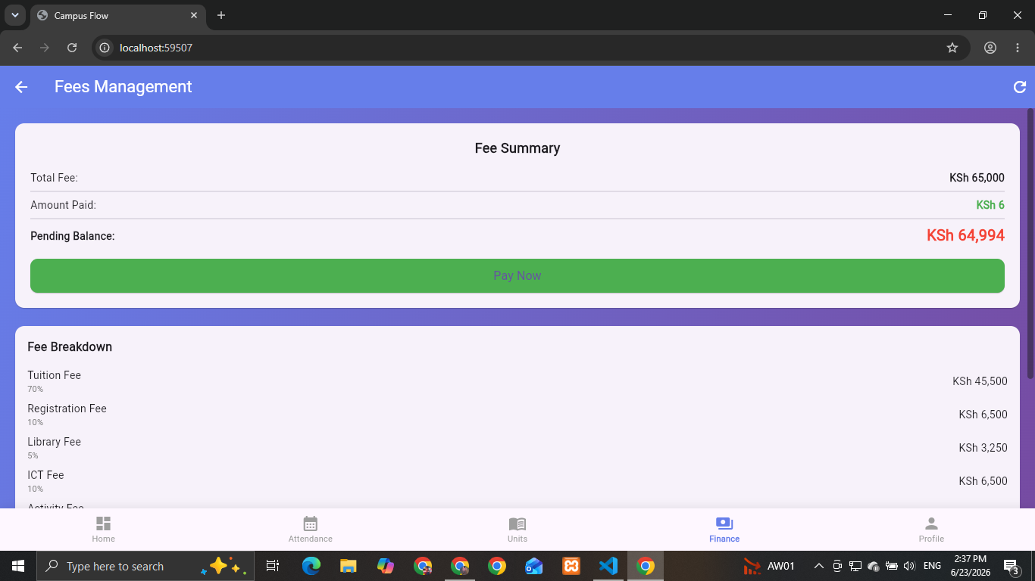
8. QR Code Generation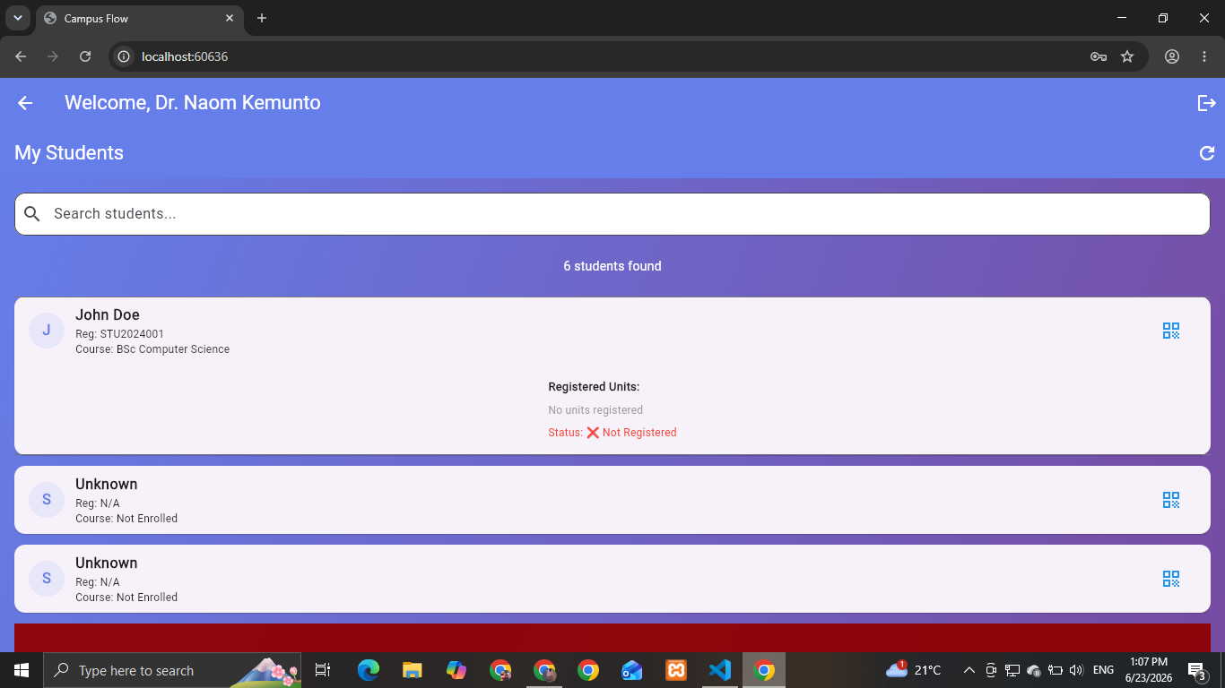
9. Payment Methods
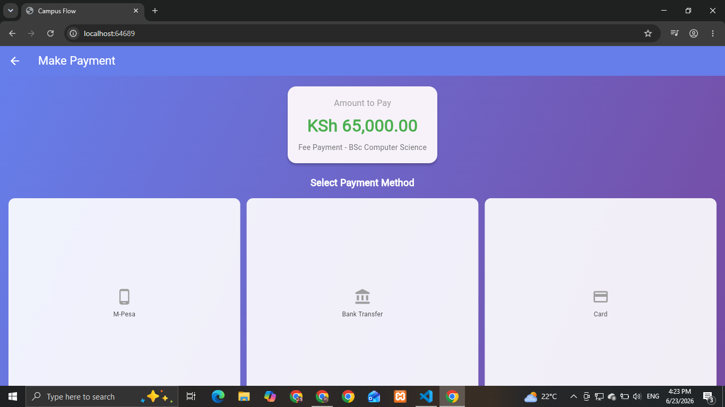
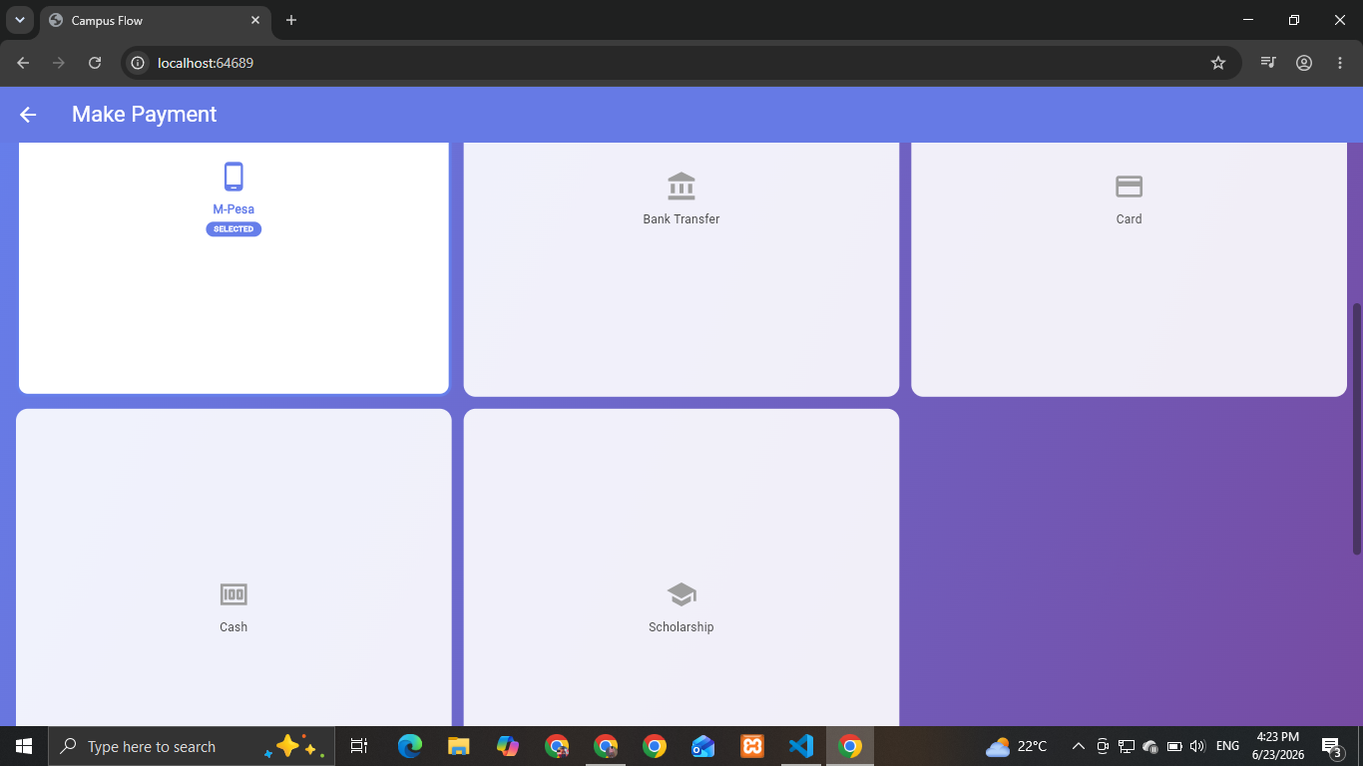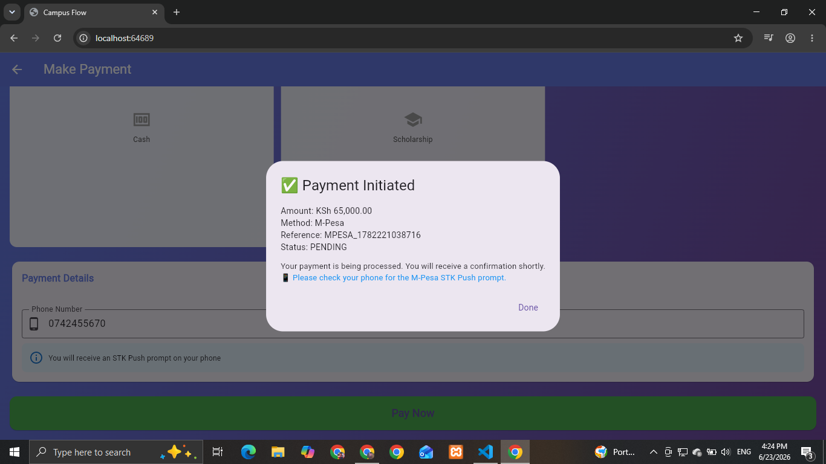
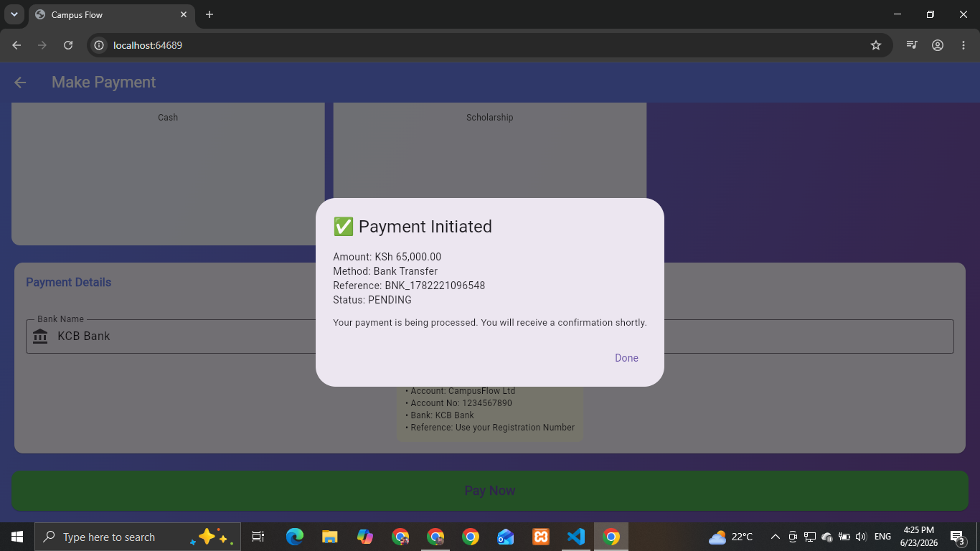
10. Support center
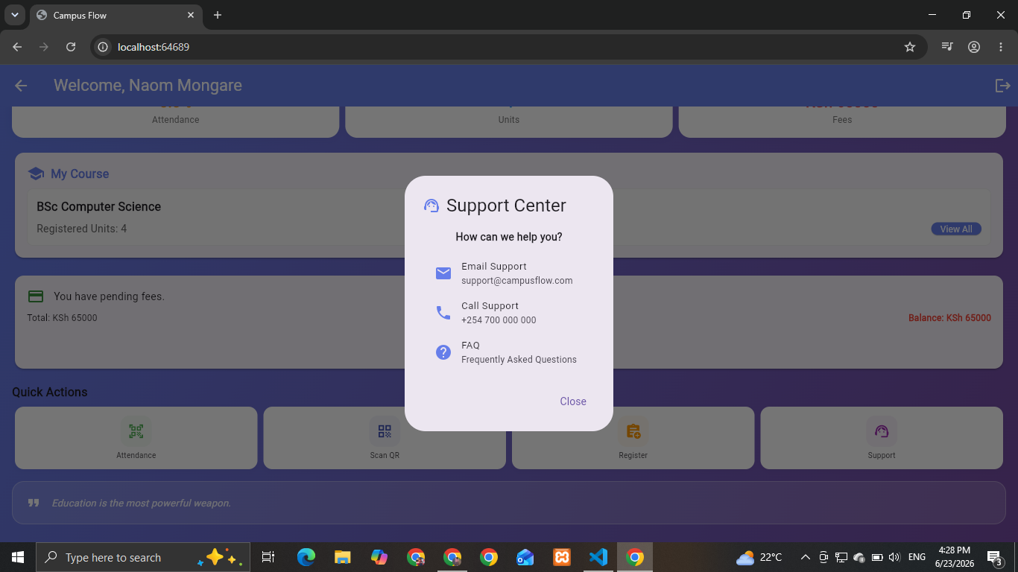

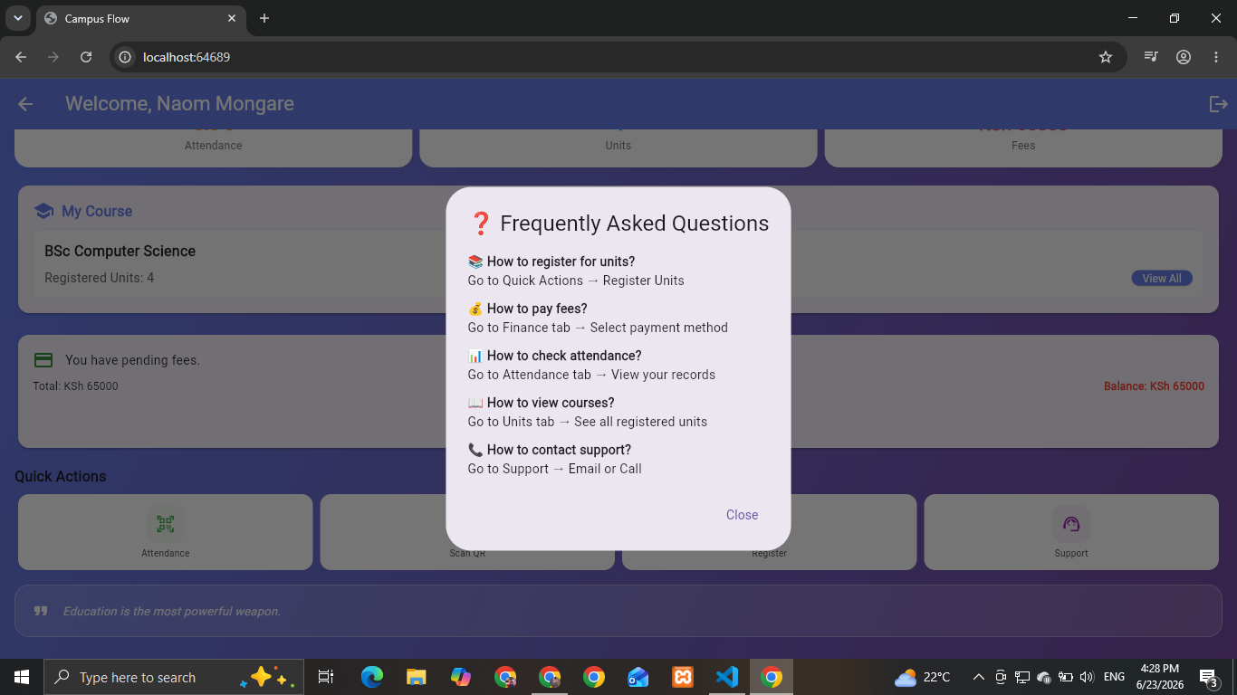
11. Network Connection a. Online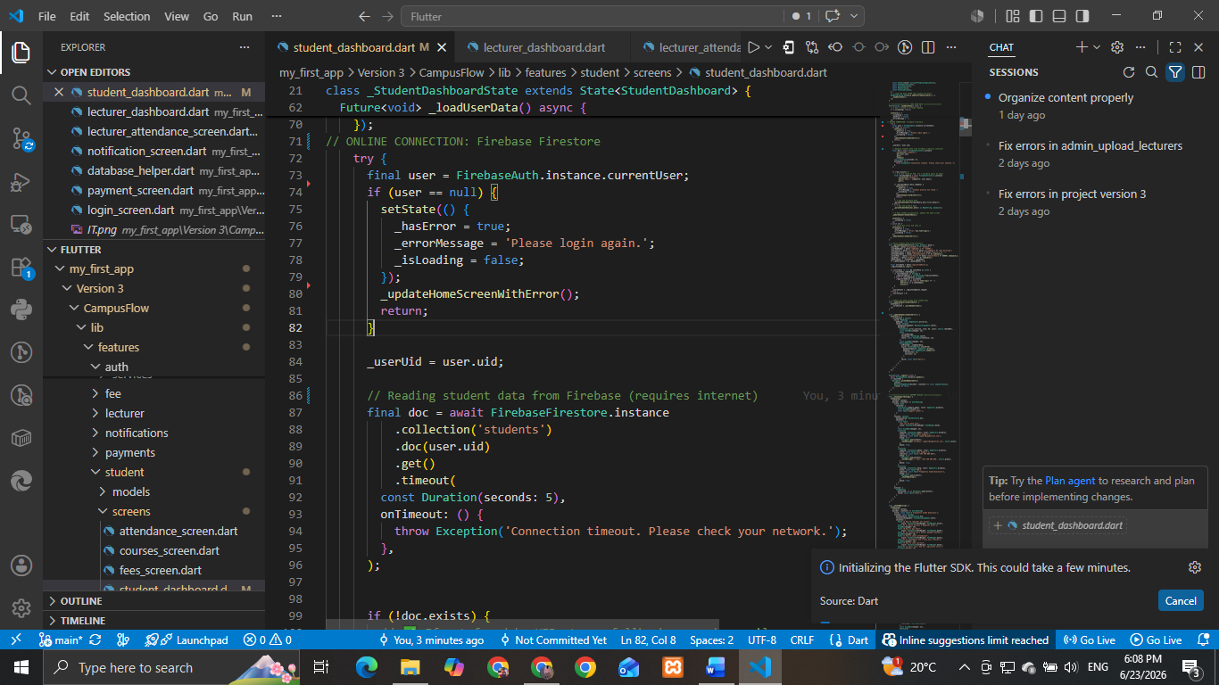
b. Offline connection
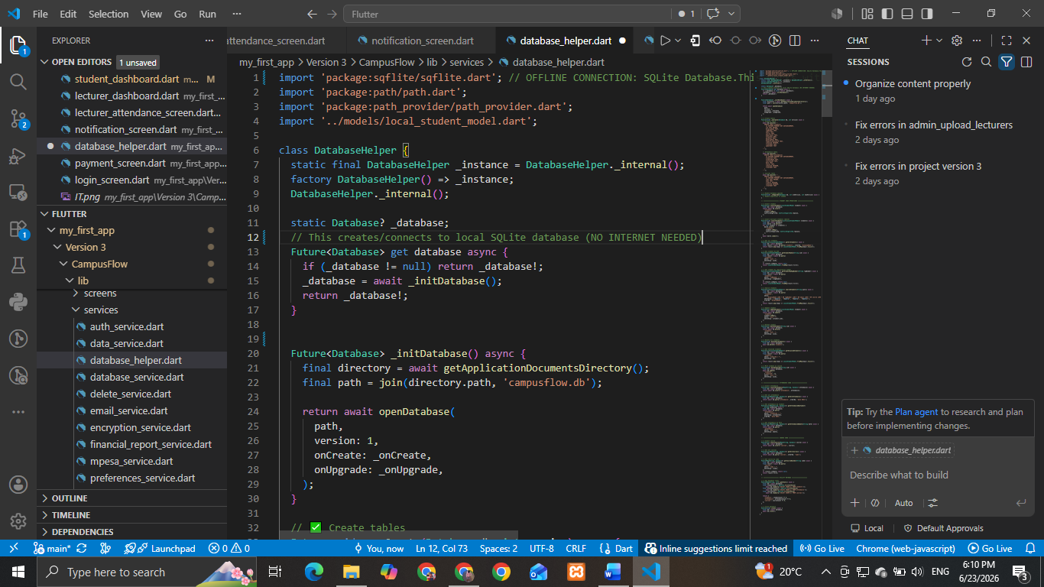12. Firebase Console 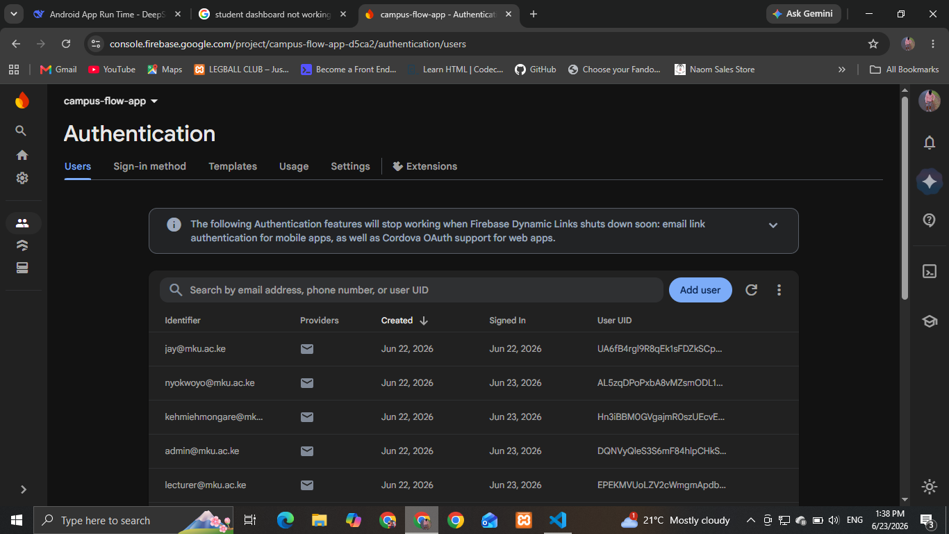
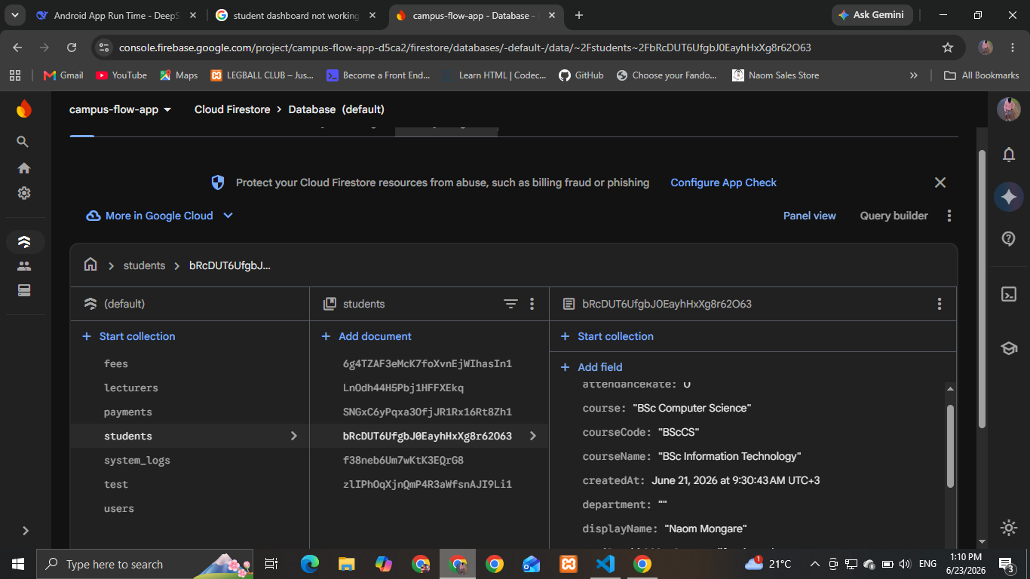
CampusFlow requires network access for Firebase authentication, real-time student data sync, attendance tracking, and payment processing.
Thank You!

